Nuevo Foundation Workshop

Sun follower project

**Difficulty: Intermediate**

**Pre-requisite: Arduino Light Game**

**I. Introduction**

* **A. Project Overview**
  + A sun follower, or solar tracker, is a device that moves solar panels to follow the sun throughout the day. This helps the panels get more sunlight and produce more energy compared to panels that stay in one place. It's like how a sunflower turns to face the sun!
  + William Kamkwamba, a young innovator from Malawi, built wind turbines and solar trackers from scrap materials to generate electricity and improve life in his village. Inspired by his story, the Nuevo Foundation designed a sun follower workshop to teach students about renewable energy. This hands-on project not only educates them about solar technology but also motivates them to pursue STEM careers and use their skills to make a positive impact on their communities, just like William did.
* **B. Project goals**
  + Educate on renewable energy: teach students about the importance and principles of solar energy.
  + Hands-On learning: provide practical experience in building and programming a sun follower.
  + Inspire innovation: motivate students to explore STEM careers and think creatively about solving real-world problems.
* **C. Importance of Solar Energy**
  + Solar energy is really important because it is a permanent source of light and warmth that comes from the Sun .It’s a clean and renewable source of power that helps us create electricity without polluting the air or harming the environment. Unlike fossil fuels, which can run out and pollute, solar energy is endless and safe for the planet. By using solar energy, we can power our homes, schools, and gadgets while taking care of Earth. It’s a smart way to help fight climate change and make sure our world stays healthy for everyone.

**II. Materials Needed**

* **A. Hardware Components**
  + 4 Light Dependent Resistors (LDR) ~ 5 USD amazon / 1 USD Aliexpress

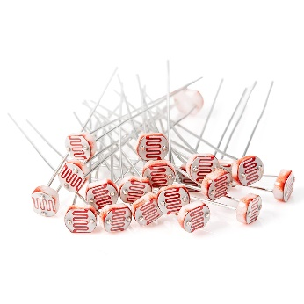

* + 4 Resistors 10kΩ ~ 5 USD amazon / 1 USD Aliexpress

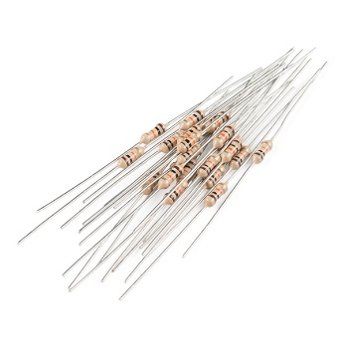

* + 2 Servo Motors (SG90) ~ 7 USD amazon / 2.5 USD Aliexpress

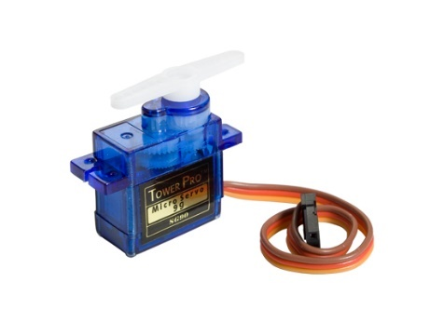

* + Arduino Nano Board ~ 7 USD amazon / 2.5 USD Aliexpress

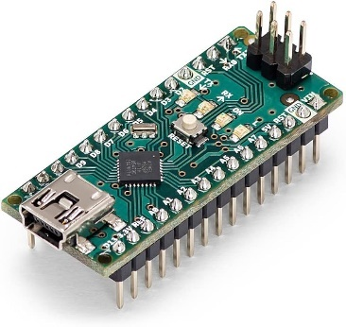

* + Breadboard and Jumper Wires ~ 10 USD amazon / 4 USD amazon

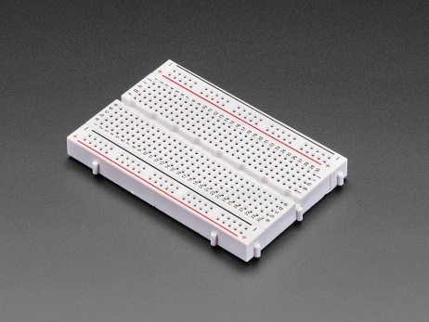 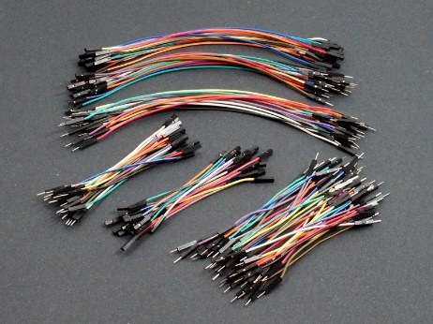

* + Power Supply (battery or USB; check voltage and USB port in controller)

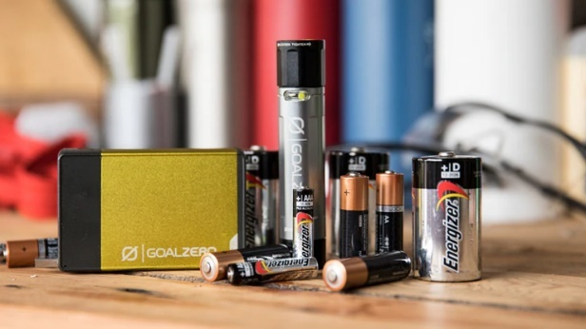 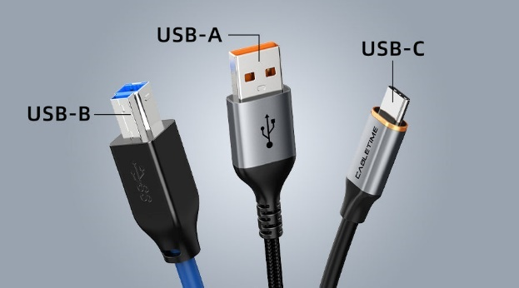

* + Base and Frame for Mounting Components (cardboard)
  + Silicone glue gun ~ 4 USD aliexpress
  + Solar cells (optional) ~ Depends on size and power
    - *Prices may vary on different websites*

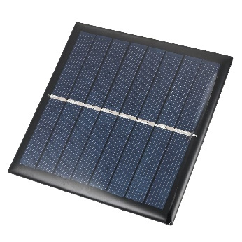

* **B. Software**
  + Arduino IDE

**III. Understanding the Components (could be an appendix)**

* **Light Dependent Resistors (LDR)**
  + Component that changes its resistance based on the light intensity it detects. In low light or darkness, the LDR's resistance is high, often in the range of megaohms, which limits the flow of electrical current. As the light intensity increases, the LDR's resistance decreases, allowing more current to pass through.
* **Resistors**
  + Resistors work by limiting the flow of electrical current in a circuit.
* **Servo Motors**
  + Servo motors work by receiving a control signal that determines their position. Inside the motor, a small circuit interprets this signal and adjusts the motor's angle accordingly, usually between 0° and 180°.
* **Arduino Nano**
  + Compact, microcontroller board. It is used for building and programming electronic projects.
* **Breadboard**
  + Reusable platforms for building and testing electronic circuits without soldering. They consist of a grid of interconnected holes where you can insert electronic components and wires.
* **Jumper wires**
  + Short, insulated wires with connectors at each end, used to make temporary electrical connections.
* **Power Supply**
  + Device that provides electrical power to a circuit or electronic device.
* **Solar Cells**
  + Devices that convert sunlight directly into electrical energy.

**IV. Building the Project**

* **A. Building the cardboard structure**
  + Cutting pieces and putting them together.
* **B. Setting Up the Breadboard**
  + Placement of Arduino Nano, LDRs, and connections.
* **C. Connecting the Servo Motors**
  + Wiring the servo motors to the Arduino Nano.
* **D. Integrating Solar Cells (optional)**
  + Connecting the solar cells to the circuit.

**V. Connecting and Coding in Arduino IDE**

* **A. Introduction to Arduino IDE**
  + Overview of the software and basic functionality.
* **B. Writing the Code**
  + Step-by-step guide to writing the code for the sun follower.
  + Explanation of each part of the code.
* **C. Uploading the Code**
  + How to upload the code to the Arduino Nano.

**VI. Testing and Calibration (optional calibration)**

* **A. Initial Testing**
  + Powering up the system and observing the initial behavior.
* **B. Calibration of LDRs**
  + Adjusting the sensitivity of the LDRs.
* **C. Fine-Tuning the Servos**
  + Ensuring the servo motors respond correctly to light changes.

**VII. Extensions**

* **A. Project Extensions**
  + Ideas for further development and enhancements.
  + Adding features like data logging, remote monitoring, etc.
  + Added stand alone feature.

**VIII. Conclusion**

* **A. Recap of the Project**
  + Summary of what was learned and achieved.
* **B. Encouragement to Explore Further**
  + Motivating students to explore more projects in renewable energy and engineering.